**4.2**

1. x <- c(‘data.science.in.R’, ‘machine.learning.in.R’)

Perform the below string Operation:

• Replace the period character "." within each string with another character i.e. "-" minus sign.

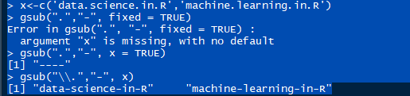

2. x <- c('data.science.in.R','machine.learning.in.R')

Perform the below String Operation:

• Append again with “-“ minus sign character at the start of the each string and finally concatenate all the string within the vector to form a final single string and assigning it the object.

